**Hands-On: Stage 3 - MVC components in Web page rendering, Data binding concepts in .Net core - Day 63 – Hands on 1**

1. **Create a Razor view to list a few Organizations at Hyderabad and highlight the one that has recently build its largest offshore office at India.**

**HomeController.cs**

using Microsoft.AspNetCore.Mvc;

using Microsoft.Extensions.Logging;

using OrganizationsAtHyderabad.Models;

using System;

using System.Collections.Generic;

using System.Diagnostics;

using System.Linq;

using System.Threading.Tasks;

namespace OrganizationsAtHyderabad.Controllers

{

    public class HomeController : Controller

    {

        private readonly ILogger<HomeController> _logger;

        public HomeController(ILogger<HomeController> logger)

        {

            _logger = logger;

        }

        public IActionResult Index()

        {

            return View();

        }

        public IActionResult Privacy()

        {

            return View();

        }

        public IActionResult ITOrganizations()

        {

            List<string> organizationList = new List<string>

            {

                "Microsoft www.microsoft.com","CTS www.cognizant.com", "Google", "Amazon","TCS"

            };

            return View(organizationList);

        }

        [ResponseCache(Duration = 0, Location = ResponseCacheLocation.None, NoStore = true)]

        public IActionResult Error()

        {

            return View(new ErrorViewModel { RequestId = Activity.Current?.Id ?? HttpContext.TraceIdentifier });

        }

    }

}

**ITOrganizations.cshtml**

@*

    For more information on enabling MVC for empty projects, visit https://go.microsoft.com/fwlink/?LinkID=397860

*@

@{

}

@model List<string>

@foreach (var organization in Model)

{

    <div>

        @if (organization.Equals("Amazon"))

        {

            <span><b>@Html.DisplayFor(o => organization)</b></span>

        }

        else

        {

            <span>@Html.DisplayFor(o => organization)</span>

        }

    </div>

}

**_Layout.cs**

<!DOCTYPE html>

<html lang="en">

<head>

    <meta charset="utf-8" />

    <meta name="viewport" content="width=device-width, initial-scale=1.0" />

    <title>@ViewData["Title"] - OrganizationsAtHyderabad</title>

    <link rel="stylesheet" href="~/lib/bootstrap/dist/css/bootstrap.min.css" />

    <link rel="stylesheet" href="~/css/site.css" />

</head>

<body>

    <header>

        <nav class="navbar navbar-expand-sm navbar-toggleable-sm navbar-light bg-white border-bottom box-shadow mb-3">

            <div class="container">

                <a class="navbar-brand" asp-area="" asp-controller="Home" asp-action="Index">OrganizationsAtHyderabad</a>

                <button class="navbar-toggler" type="button" data-toggle="collapse" data-target=".navbar-collapse" aria-controls="navbarSupportedContent"

                        aria-expanded="false" aria-label="Toggle navigation">

                    <span class="navbar-toggler-icon"></span>

                </button>

                <div class="navbar-collapse collapse d-sm-inline-flex flex-sm-row-reverse">

                    <ul class="navbar-nav flex-grow-1">

                        <li class="nav-item">

                            <a class="nav-link text-dark" asp-area="" asp-controller="Home" asp-action="Index">Home</a>

                        </li>

                        <li class="nav-item">

                            <a class="nav-link text-dark" asp-area="" asp-controller="Home" asp-action="Privacy">Privacy</a>

                        </li>

                        <li class="nav-item">

                            <a class="nav-link text-dark" asp-area="" asp-controller="Home" asp-action="ITOrganizations">ITOrganizations</a>

                        </li>

                    </ul>

                </div>

            </div>

        </nav>

    </header>

    <div class="container">

        <main role="main" class="pb-3">

            @RenderBody()

        </main>

    </div>

    <footer class="border-top footer text-muted">

        <div class="container">

            &copy; 2021 - OrganizationsAtHyderabad - <a asp-area="" asp-controller="Home" asp-action="Privacy">Privacy</a>

        </div>

    </footer>

    <script src="~/lib/jquery/dist/jquery.min.js"></script>

    <script src="~/lib/bootstrap/dist/js/bootstrap.bundle.min.js"></script>

    <script src="~/js/site.js" asp-append-version="true"></script>

    @RenderSection("Scripts", required: false)

</body>

</html>

**OUTPUT**

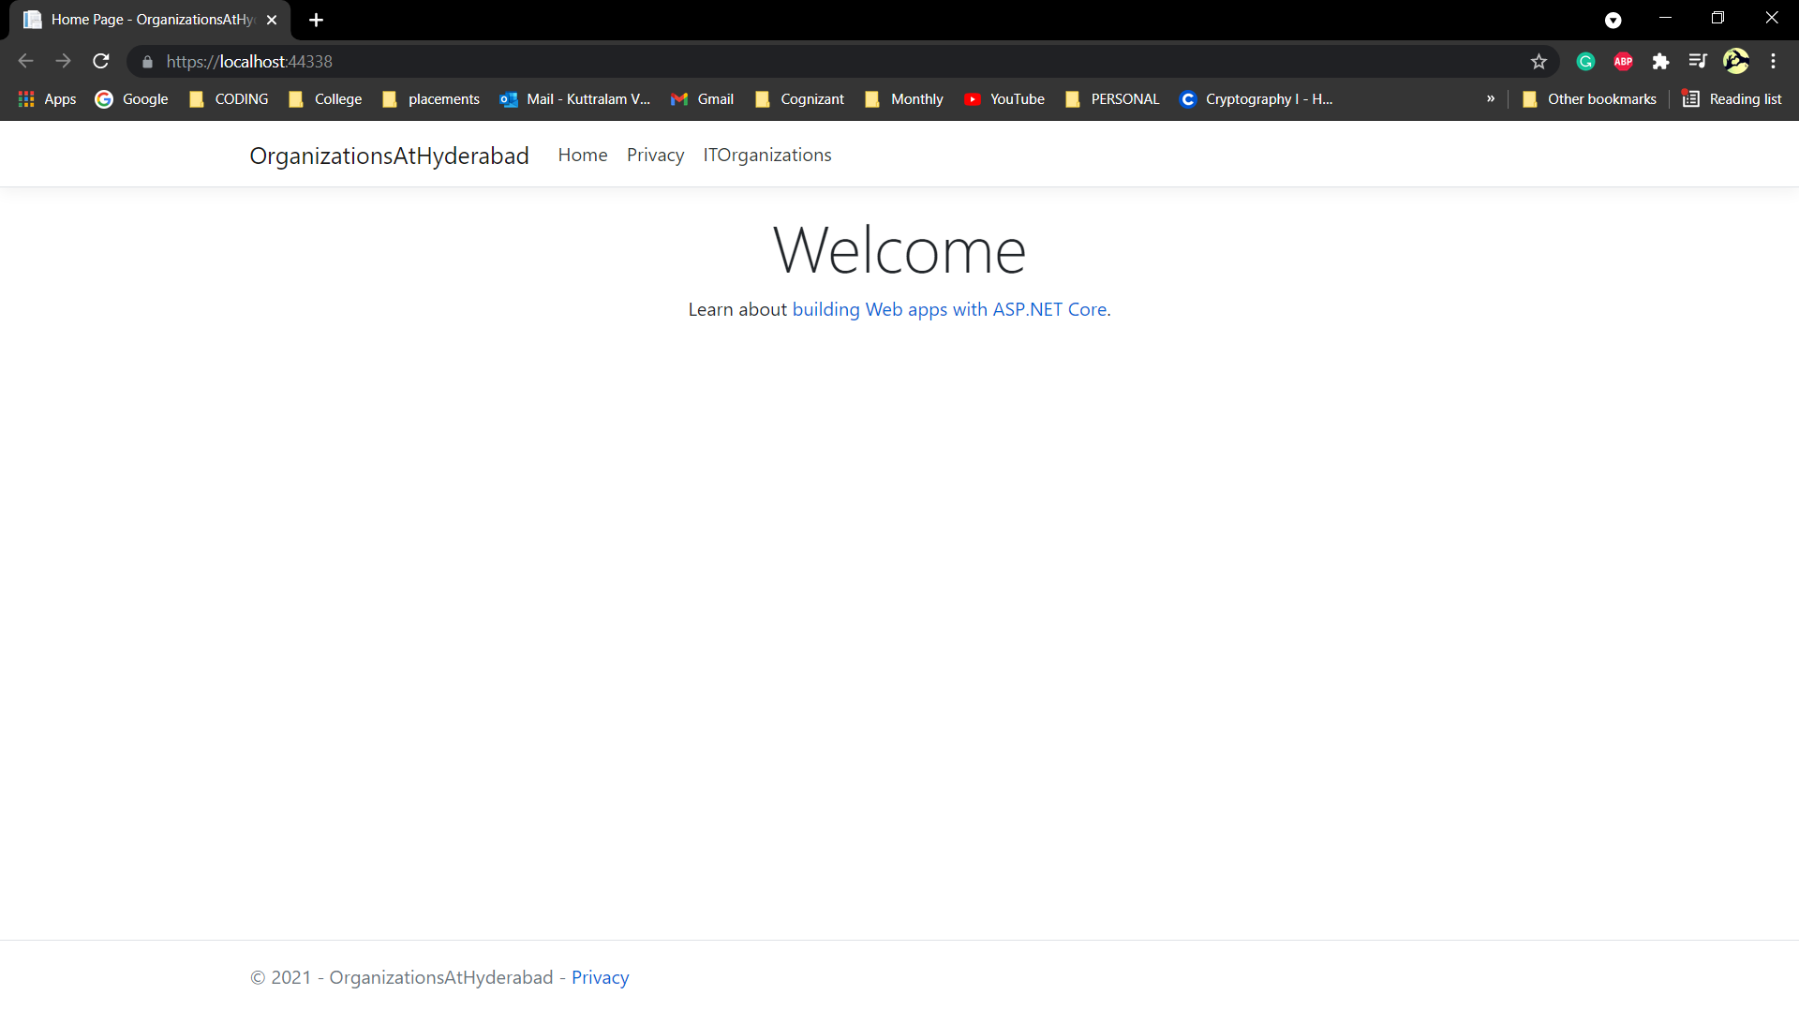

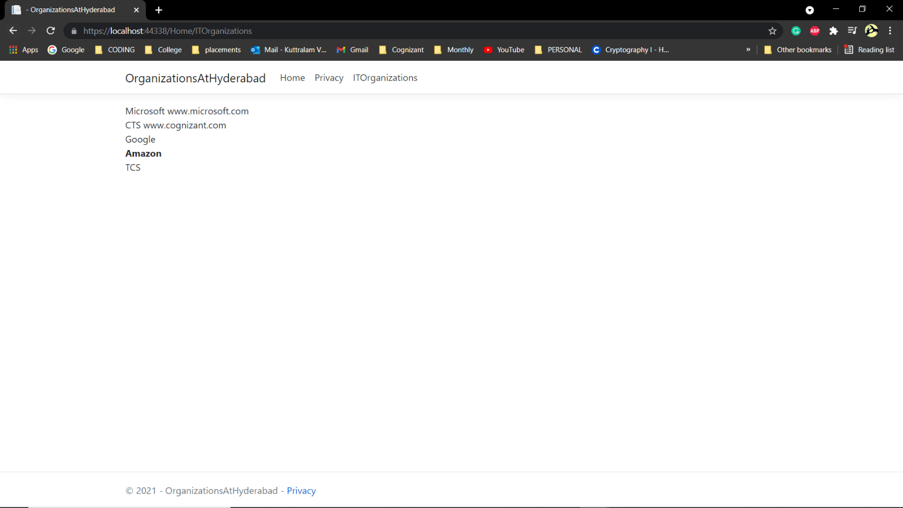

1. **Create a Razor view to list few employee details using Model data binding.**

**Employee.cs**

using System;

using System.Collections.Generic;

using System.Linq;

using System.Threading.Tasks;

namespace EmployeeDetails.Models

{

    public class Employee

    {

        public int Id { get; set; }

        public string Name { get; set; }

        public decimal Salary { get; set; }

        public bool IsPermanent { get; set; }

    }

}

**HomeController.cs**

using EmployeeDetails.Models;

using Microsoft.AspNetCore.Mvc;

using Microsoft.Extensions.Logging;

using System;

using System.Collections.Generic;

using System.Diagnostics;

using System.Linq;

using System.Threading.Tasks;

namespace EmployeeDetails.Controllers

{

    public class HomeController : Controller

    {

        private readonly ILogger<HomeController> _logger;

        public HomeController(ILogger<HomeController> logger)

        {

            _logger = logger;

        }

        public IActionResult Index()

        {

            return View();

        }

        public IActionResult Privacy()

        {

            return View();

        }

        public IActionResult GetEmployeeList()

        {

            List<Employee> employeeList = new List<Employee>();

            employeeList.Add(new Employee()

            {

                Id = 1,

                Name = "John",

                Salary = 10000,

                IsPermanent = true

            });

            employeeList.Add(new Employee()

            {

                Id = 2,

                Name = "Smith",

                Salary = 5000,

                IsPermanent = false

            });

            employeeList.Add(new Employee()

            {

                Id = 3,

                Name = "Mark",

                Salary = 5000,

                IsPermanent = false

            });

            employeeList.Add(new Employee()

            {

                Id = 4,

                Name = "Mary",

                Salary = 5000,

                IsPermanent = false

            });

            return View(employeeList);

        }

        [ResponseCache(Duration = 0, Location = ResponseCacheLocation.None, NoStore = true)]

        public IActionResult Error()

        {

            return View(new ErrorViewModel { RequestId = Activity.Current?.Id ?? HttpContext.TraceIdentifier });

        }

    }

}

**GetEmployeeList.cshtml**

@*

    For more information on enabling MVC for empty projects, visit https://go.microsoft.com/fwlink/?LinkID=397860

*@

@model List<EmployeeDetails.Models.Employee>

@{

    ViewData["Title"] = "GetEmployeeList";

    <div class="row">

        <span class="col-md-4">Name</span>

        <span class="col-md-4">Salary</span>

        <span class="col-md-4">IsPermanent</span>

    </div>

}

@foreach (var employee in Model)

{

    <div class="row">

        @if (employee.IsPermanent.Equals(true))

        {

            <span class="col-md-4"><b>@employee.Name</b></span>

            <span class="col-md-4"><b>@employee.Salary</b></span>

            <span class="col-md-4"><b>@employee.IsPermanent</b></span>

        }

        else

        {

            <span class="col-md-4">@employee.Name</span>

            <span class="col-md-4">@employee.Salary</span>

            <span class="col-md-4">@employee.IsPermanent</span>

        }

    </div>

}

**_Layout.cshtml**

<!DOCTYPE html>

<html lang="en">

<head>

    <meta charset="utf-8" />

    <meta name="viewport" content="width=device-width, initial-scale=1.0" />

    <title>@ViewData["Title"] - EmployeeDetails</title>

    <link rel="stylesheet" href="~/lib/bootstrap/dist/css/bootstrap.min.css" />

    <link rel="stylesheet" href="~/css/site.css" />

</head>

<body>

    <header>

        <nav class="navbar navbar-expand-sm navbar-toggleable-sm navbar-light bg-white border-bottom box-shadow mb-3">

            <div class="container">

                <a class="navbar-brand" asp-area="" asp-controller="Home" asp-action="Index">EmployeeDetails</a>

                <button class="navbar-toggler" type="button" data-toggle="collapse" data-target=".navbar-collapse" aria-controls="navbarSupportedContent"

                        aria-expanded="false" aria-label="Toggle navigation">

                    <span class="navbar-toggler-icon"></span>

                </button>

                <div class="navbar-collapse collapse d-sm-inline-flex flex-sm-row-reverse">

                    <ul class="navbar-nav flex-grow-1">

                        <li class="nav-item">

                            <a class="nav-link text-dark" asp-area="" asp-controller="Home" asp-action="Index">Home</a>

                        </li>

                        <li class="nav-item">

                            <a class="nav-link text-dark" asp-area="" asp-controller="Home" asp-action="Privacy">Privacy</a>

                        </li>

                        <li class="nav-item">

                            <a class="nav-link text-dark" asp-area="" asp-controller="Home" asp-action="GetEmployeeList">GetEmployeeList</a>

                        </li>

                    </ul>

                </div>

            </div>

        </nav>

    </header>

    <div class="container">

        <main role="main" class="pb-3">

            @RenderBody()

        </main>

    </div>

    <footer class="border-top footer text-muted">

        <div class="container">

            &copy; 2021 - EmployeeDetails - <a asp-area="" asp-controller="Home" asp-action="Privacy">Privacy</a>

        </div>

    </footer>

    <script src="~/lib/jquery/dist/jquery.min.js"></script>

    <script src="~/lib/bootstrap/dist/js/bootstrap.bundle.min.js"></script>

    <script src="~/js/site.js" asp-append-version="true"></script>

    @RenderSection("Scripts", required: false)

</body>

</html>

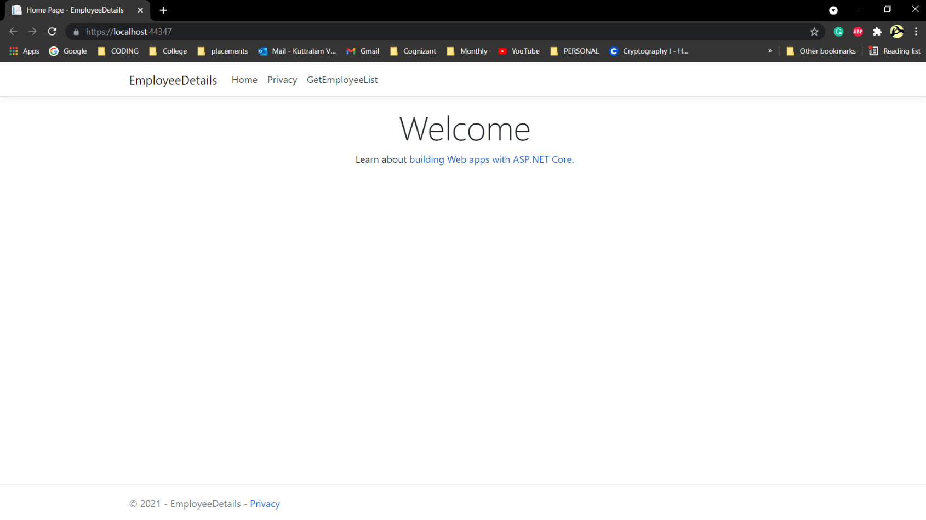**OUTPUT**

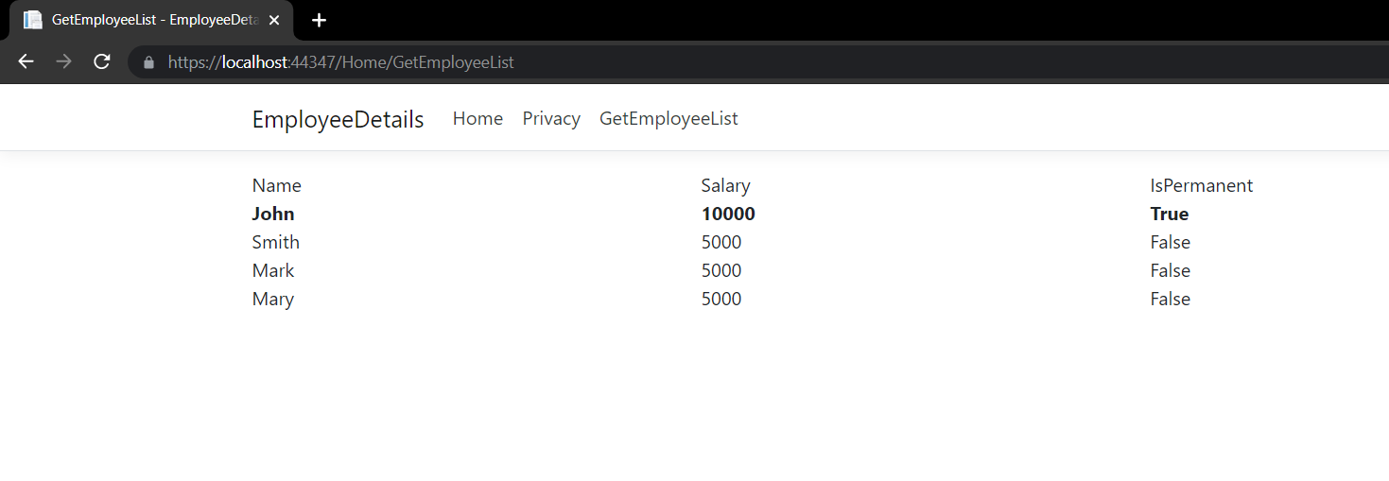

1. **Demonstrate partial view usage.**

**Employee.cs**

using System;

using System.Collections.Generic;

using System.Linq;

using System.Threading.Tasks;

namespace EmployeeDetails.Models

{

    public class Employee

    {

        public int Id { get; set; }

        public string Name { get; set; }

        public decimal Salary { get; set; }

        public bool IsPermanent { get; set; }

    }

}

**HomeController.cs**

using EmployeeDetails.Models;

using Microsoft.AspNetCore.Mvc;

using Microsoft.Extensions.Logging;

using System;

using System.Collections.Generic;

using System.Diagnostics;

using System.Linq;

using System.Threading.Tasks;

namespace EmployeeDetails.Controllers

{

    public class HomeController : Controller

    {

        private readonly ILogger<HomeController> _logger;

        public HomeController(ILogger<HomeController> logger)

        {

            _logger = logger;

        }

        public IActionResult Index()

        {

            return View();

        }

        public IActionResult Privacy()

        {

            return View();

        }

        public IActionResult GetEmployeeList()

        {

            List<Employee> employeeList = new List<Employee>();

            employeeList.Add(new Employee()

            {

                Id = 1,

                Name = "John",

                Salary = 10000,

                IsPermanent = true

            });

            employeeList.Add(new Employee()

            {

                Id = 2,

                Name = "Smith",

                Salary = 5000,

                IsPermanent = false

            });

            employeeList.Add(new Employee()

            {

                Id = 3,

                Name = "Mark",

                Salary = 5000,

                IsPermanent = false

            });

            employeeList.Add(new Employee()

            {

                Id = 4,

                Name = "Mary",

                Salary = 5000,

                IsPermanent = false

            });

            return View(employeeList);

        }

        [ResponseCache(Duration = 0, Location = ResponseCacheLocation.None, NoStore = true)]

        public IActionResult Error()

        {

            return View(new ErrorViewModel { RequestId = Activity.Current?.Id ?? HttpContext.TraceIdentifier });

        }

    }

}

**GetEmployeeList.cshtml**

@*

    For more information on enabling MVC for empty projects, visit https://go.microsoft.com/fwlink/?LinkID=397860

*@

@{

}

<partial name="partialGetEmployeeList"/>

**partialGetEmployeeList.cshtml**

@*

    For more information on enabling MVC for empty projects, visit https://go.microsoft.com/fwlink/?LinkID=397860

*@

@model List<EmployeeDetails.Models.Employee>

@{

    ViewData["Title"] = "GetEmployeeList";

    <div class="row">

        <span class="col-md-4">Name</span>

        <span class="col-md-4">Salary</span>

        <span class="col-md-4">IsPermanent</span>

    </div>

}

@foreach (var employee in Model)

{

    <div class="row">

        @if (employee.IsPermanent.Equals(true))

        {

            <span class="col-md-4"><b>@employee.Name</b></span>

            <span class="col-md-4"><b>@employee.Salary</b></span>

            <span class="col-md-4"><b>@employee.IsPermanent</b></span>

        }

        else

        {

            <span class="col-md-4">@employee.Name</span>

            <span class="col-md-4">@employee.Salary</span>

            <span class="col-md-4">@employee.IsPermanent</span>

        }

    </div>

}

**_Layout.cshtml**

<!DOCTYPE html>

<html lang="en">

<head>

    <meta charset="utf-8" />

    <meta name="viewport" content="width=device-width, initial-scale=1.0" />

    <title>@ViewData["Title"] - EmployeeDetails</title>

    <link rel="stylesheet" href="~/lib/bootstrap/dist/css/bootstrap.min.css" />

    <link rel="stylesheet" href="~/css/site.css" />

</head>

<body>

    <header>

        <nav class="navbar navbar-expand-sm navbar-toggleable-sm navbar-light bg-white border-bottom box-shadow mb-3">

            <div class="container">

                <a class="navbar-brand" asp-area="" asp-controller="Home" asp-action="Index">EmployeeDetails</a>

                <button class="navbar-toggler" type="button" data-toggle="collapse" data-target=".navbar-collapse" aria-controls="navbarSupportedContent"

                        aria-expanded="false" aria-label="Toggle navigation">

                    <span class="navbar-toggler-icon"></span>

                </button>

                <div class="navbar-collapse collapse d-sm-inline-flex flex-sm-row-reverse">

                    <ul class="navbar-nav flex-grow-1">

                        <li class="nav-item">

                            <a class="nav-link text-dark" asp-area="" asp-controller="Home" asp-action="Index">Home</a>

                        </li>

                        <li class="nav-item">

                            <a class="nav-link text-dark" asp-area="" asp-controller="Home" asp-action="Privacy">Privacy</a>

                        </li>

                        <li class="nav-item">

                            <a class="nav-link text-dark" asp-area="" asp-controller="Home" asp-action="GetEmployeeList">GetEmployeeList</a>

                        </li>

                    </ul>

                </div>

            </div>

        </nav>

    </header>

    <div class="container">

        <main role="main" class="pb-3">

            @RenderBody()

        </main>

    </div>

    <footer class="border-top footer text-muted">

        <div class="container">

            &copy; 2021 - EmployeeDetails - <a asp-area="" asp-controller="Home" asp-action="Privacy">Privacy</a>

        </div>

    </footer>

    <script src="~/lib/jquery/dist/jquery.min.js"></script>

    <script src="~/lib/bootstrap/dist/js/bootstrap.bundle.min.js"></script>

    <script src="~/js/site.js" asp-append-version="true"></script>

    @RenderSection("Scripts", required: false)

</body>

</html>

**OUTPUT**

